**Article ID:** 500 New a

**Article Name:** Find user Manual

**Topic Location:** Laundry / Washing Machine/

**Meta-data:** product, model, code

**Related Articles:**

**Related Questions:**

PNC

DIY

Safety

Link

Email

Book Engineer

Multimedia

Brand

**Article Content:**

Information for a specific model is available on the Service Manual for that washing machine.

[With the PNC, find the specific User Manual for the washing machine.](http://www.electrolux-ui.com/)

Where is Product Number Code (PNC) of the washing machine?

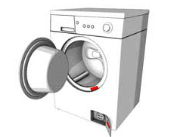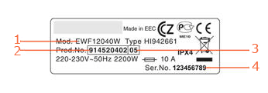

|  |  |
| --- | --- |
| 1. Model number | 3. ML code |
| 2. Product number code (PNC) | 4. Serial number |